**<>**

**Data Specification**

Version <>

# Revision History

|  |  |  |  |
| --- | --- | --- | --- |
| Date | Version | Description | Author |
| <MM/DD/YYYY> | <version> | <description> | <author> |
|  |  |  |  |
|  |  |  |  |

# Table of Contents

Revision History 2

Table of Contents 3

Introduction 4

Purpose 4

Scope 4

Definition, Acronyms and Abbreviations 4

References 4

Database Design 4

Data Dictionary 4

Appendices 4

# Introduction

<Introduction of this Data Specification. What will be covered in this document? What is the aim of this document? What are the main focuses? >

## Purpose

<Purpose of this document. Do you write this document to describe the current database? Do you write this document as a guide to develop a new database? Do you expect the end user will gain a better understanding of the data structure by reading this document? Do others like system designer and developer to gain understanding of the data structure by reading this document?>

## Scope

<Scope of this document. What parties or systems will be mentioned or focused? Will you talk about the stakeholders, the existing process and computer system in-use?>

## Definition, Acronyms and Abbreviations

<Collection of terms to be used in this document, with their definition. For example, you may want to describe the word ‘legacy’ that appears in your entity description>

|  |  |
| --- | --- |
| Term | Definition |
|  |  |

## References

<A list of reference material used by this document.>

# Database Design

## Entity Relationship Diagram1

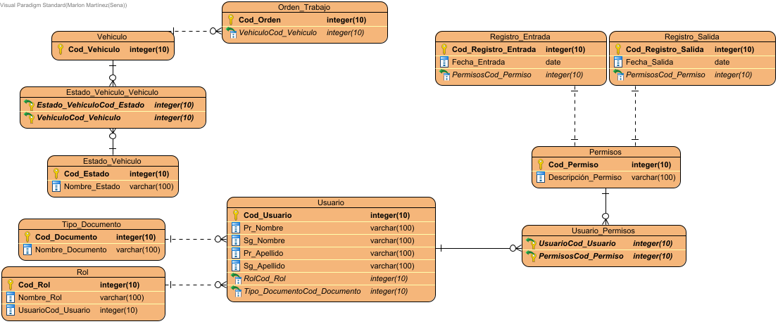

# Data Dictionary

## Data Dictionary

|  |  |  |  |  |  |  |  |  |  |
| --- | --- | --- | --- | --- | --- | --- | --- | --- | --- |
| Entity Name | Entity Description | |  |  |  |  |  |  |  | | --- | --- | --- | --- | --- | --- | --- | | Column Name | Column Description | Data Type | Length | Primary Key | Nullable | Unique | |
| Estado_Vehiculo | Tabla de estado de los vehiculos | | Cod_Estado | Codigo unico del estado del vehiculo | integer | 10 | true | false | false | | --- | --- | --- | --- | --- | --- | --- | | Nombre_Estado | Descripción breve del nombre del estado | varchar | 100 | false | false | false | |
| Estado_Vehiculo_Vehiculo |  | | Estado_VehiculoCod_Estado |  | integer | 10 | true | false | false | | --- | --- | --- | --- | --- | --- | --- | | VehiculoCod_Vehiculo |  | integer | 10 | true | false | false | |
| Orden_Trabajo |  | | Cod_Orden | Codigo unico de la ordenes de trabajo que se le creen a los vehiculos en estado de mantenimiento | integer | 10 | true | false | false | | --- | --- | --- | --- | --- | --- | --- | | VehiculoCod_Vehiculo |  | integer | 10 | false | false | false | |
| Permisos | Tabla de los permisos que existiran | | Cod_Permiso | Codigo unico del permiso | integer | 10 | true | false | false | | --- | --- | --- | --- | --- | --- | --- | | Descripción_Permiso | Descripción breve del permiso | varchar | 100 | false | false | false | |
| Registro_Entrada |  | | Cod_Registro_Entrada | Codigo de cada registro de entrada de los vehiculos | integer | 10 | true | false | false | | --- | --- | --- | --- | --- | --- | --- | | Fecha_Entrada | Fecha de entrada del vehiculo | date | 0 | false | false | false | | PermisosCod_Permiso |  | integer | 10 | false | false | false | |
| Registro_Salida |  | | Cod_Registro_Salida | Codigo unico de todas las salidas de los vehiculos | integer | 10 | true | false | false | | --- | --- | --- | --- | --- | --- | --- | | Fecha_Salida | Fecha de salida de los vehiculos | date | 0 | false | false | false | | PermisosCod_Permiso |  | integer | 10 | false | false | false | |
| Rol | Tabla de los roles | | Cod_Rol | Codigo unico del rol | integer | 10 | true | false | false | | --- | --- | --- | --- | --- | --- | --- | | Nombre_Rol | Descripción breve del nombre del rol | varchar | 100 | false | false | false | | UsuarioCod_Usuario |  | integer | 10 | false | false | false | |
| Tipo_Documento | Tabla de los tipos de documentos | | Cod_Documento | Codigo unico del tipo documento | integer | 10 | true | false | false | | --- | --- | --- | --- | --- | --- | --- | | Nombre_Documento | Descripción breve del tipo de documento | varchar | 100 | false | false | false | |
| Usuario | Tabla de Usuarios | | Cod_Usuario | Codigo unico de usuario | integer | 10 | true | false | false | | --- | --- | --- | --- | --- | --- | --- | | Pr_Apellido | Primer apellido del usuario | varchar | 100 | false | false | false | | Pr_Nombre | Primero nombre del usuario | varchar | 100 | false | false | false | | RolCod_Rol |  | integer | 10 | false | false | false | | Sg_Apellido | Segundo apellido del usuario | varchar | 100 | false | false | false | | Sg_Nombre | Segundo nombre del usuario | varchar | 100 | false | false | false | | Tipo_DocumentoCod_Documento |  | integer | 10 | false | false | false | |
| Usuario_Permisos |  | | PermisosCod_Permiso |  | integer | 10 | true | false | false | | --- | --- | --- | --- | --- | --- | --- | | UsuarioCod_Usuario |  | integer | 10 | true | false | false | |
| Vehiculo | Tabla de los vehiculos | |  |  |  |  |  |  |  | | --- | --- | --- | --- | --- | --- | --- | | Cod_Vehiculo | Codigo interno que contiene el vehiculo | integer | 10 | true | false | false | |

# Appendices